**Code Usage Consent Agreement**

This agreement is made on 21/06/2025 between the following parties:

* Daniel López Ramos, Iván Miranda Balastegui and Diego Terrón Hernández, hereinafter referred to as “the Users”, and
* Aaron Mayoral Ansias and Estrella del Carmen Ángel Postigo**,** hereinafter referred to as “the Contributors”.

**Purpose:**  
The Contributors agree to grant the Users permission to use the source code they have authored for academic purposes related to the project entitled *Acme-ANS*, submitted as part of the coursework for the second call of the subject *Diseño y Pruebas II.*

**Terms of Use:**

1. The granted code may only be used for academic and non-commercial purposes.
2. This agreement does not transfer any intellectual property rights beyond the scope of this academic use.

**Signatures:**

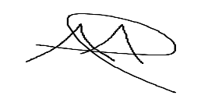

Aaron Mayoral Ansias  
Date: 21/06/2025

Estrella del Carmen Ángel Postigo  
Date: 21/06/2025



Daniel López Ramos  
Date: 21/06/2025



Iván Miranda Balastegui  
Date: 21/06/2025

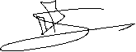

Diego Terrón Hernández  
Date: 21/06/2025

